Lighthouse Research Paper
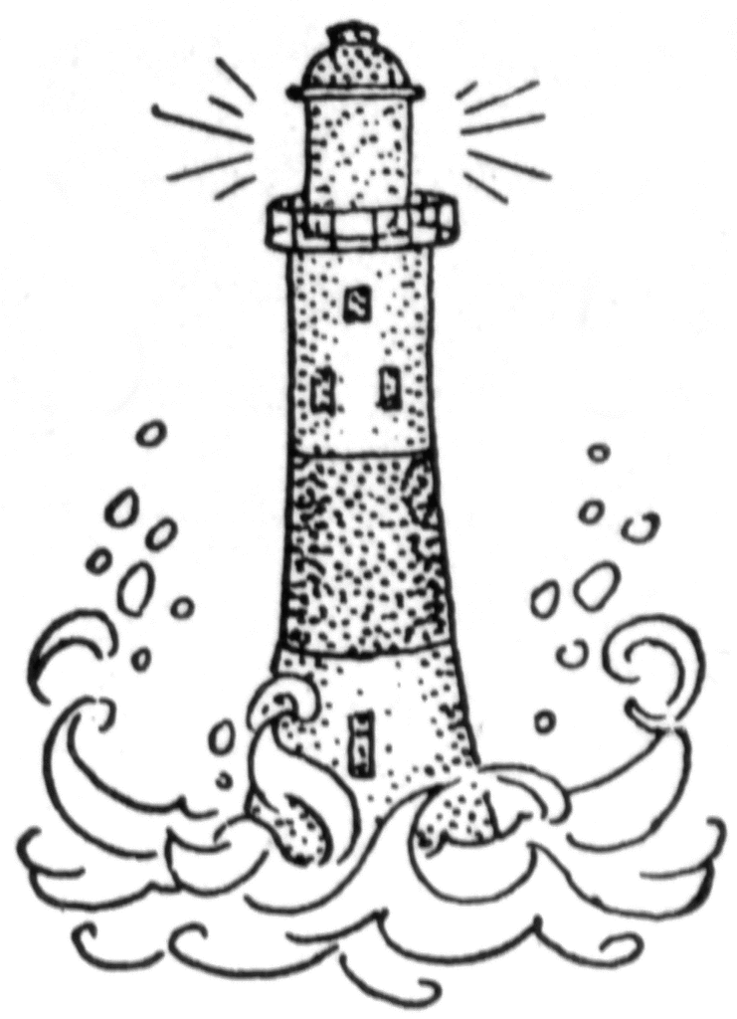

As part of your lighthouse research, you will be expected to write a three (3) paragraph essay about your lighthouse. Use this paper to guide you as you write your research paper. (Remember to use the information that you gathered on your note-taking sheets) This sheet can be used for your rough draft. You may write neatly (pencil or pen – no scribble outs) or type your published paper.

Please include:

Introduction Paragraph:
- The main idea for this paragraph will be general information about lighthouses. Begin it with a bold beginning!!
- What is the lighthouse’s use or purpose?
- Name at least three (3) types of lighthouse structures.
- Where are lighthouses generally located?
- How do lighthouses signal in the day vs. the night

Paragraph Two:
- The main idea about this paragraph will be to tell about your lighthouse. Make this a mighty middle – be descriptive!!
- Name of your lighthouse?
- Location of your lighthouse? (State, City, Waterway – river, lake, ocean)
- The year it was constructed? To include how old it is (take 2016 and subtract the year it constructed)
- Describe your lighthouse: color, shape, height, structures, and beacon color.

Paragraph Three:
- The main idea for this paragraph will be to reflect about what you have learned. Wrap it up with an exciting ending!!
- What did you find most interesting about your lighthouse?
- What fun fact did you find out about your lighthouse?
- Because of this project, would you like to visit a lighthouse or your lighthouse?

Lighthouse Research Note Page

Use this page to take notes as you research.

- What is the purpose of a lighthouse? Why and how are they used?
____________________________________________________________________________________________________________________________________________________________________________________________________________________________________________________________________
- What are the types of lighthouse structures? ____________________________________________________________________________________________________________________________________________________________________________________________________________________________________________________________________
- Where are most lighthouses generally located? (On land vs. in the water) ____________________________________________________________________________________________________________________________________________________________________________________________________________________________________________________________________
- How do lighthouses signal? Day vs. Night signaling? ____________________________________________________________________________________________________________________________________________________________________________________________________________________________________________________________________

- What is the name of your lighthouse?
____________________________________________________

- Where is your lighthouse located?

- State: ___________________________________________
- Nearest City: _______________________________________
- On which waterway(s) (river, lake, or ocean) is your lighthouse located? __________________________________________
_________________________________________________
- When was your lighthouse constructed?
___________________________________________________

- How old is your lighthouse? ______________________________
(Take 2017 and subtract the year your lighthouse was constructed.)

- What shape is your lighthouse? Is it a cylinder, conical, rectangle, square, octagonal? Is it brick, stone masonry, skeleton, or other? Describe it the best you can.
____________________________________________________________________________________________________________________________________________________________

- Interesting facts and fun facts about your lighthouse:
____________________________________________________________________________________________________________________________________________________________________________________________________________________________________________________________________

